NAAN MUDHAVAN ASSIGNMENT DOCUMENT

**COURSE TITLE** : DIGITAL MARKETING

**COLLEGE CODE** 1105

**COLLEGE NAME** : GOJAN SCHOOL OF BUSINESS AND TECHNOLOGY

**NM ID** : 445D7708D401D6F89684C91AFD22C748

**NAME** : KOWSALYA S

**REGISTER NUMBER** 110520106901

**YEAR** : 4TH YEAR

**DEPARTMENT** : ELECTRONICS AND COMMUNICATION ENGINEERING

1. Create a blog or website using Blogspot and Wordpress. Customize the theme design and post new article with 500 words.

Link: <https://kowsalyabakery.blogspot.com/2023/10/kowsalya-bakery.html>

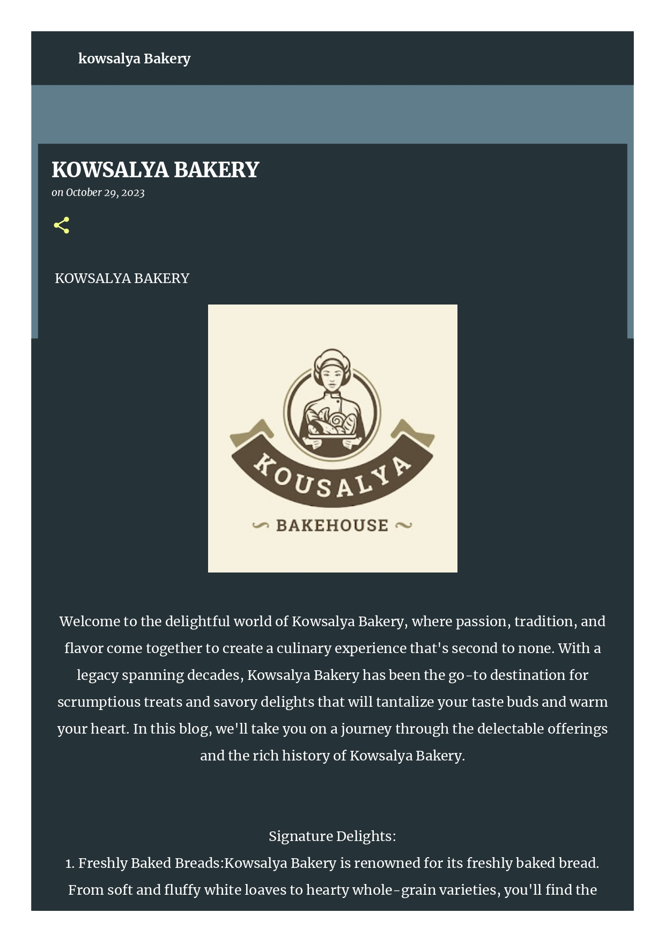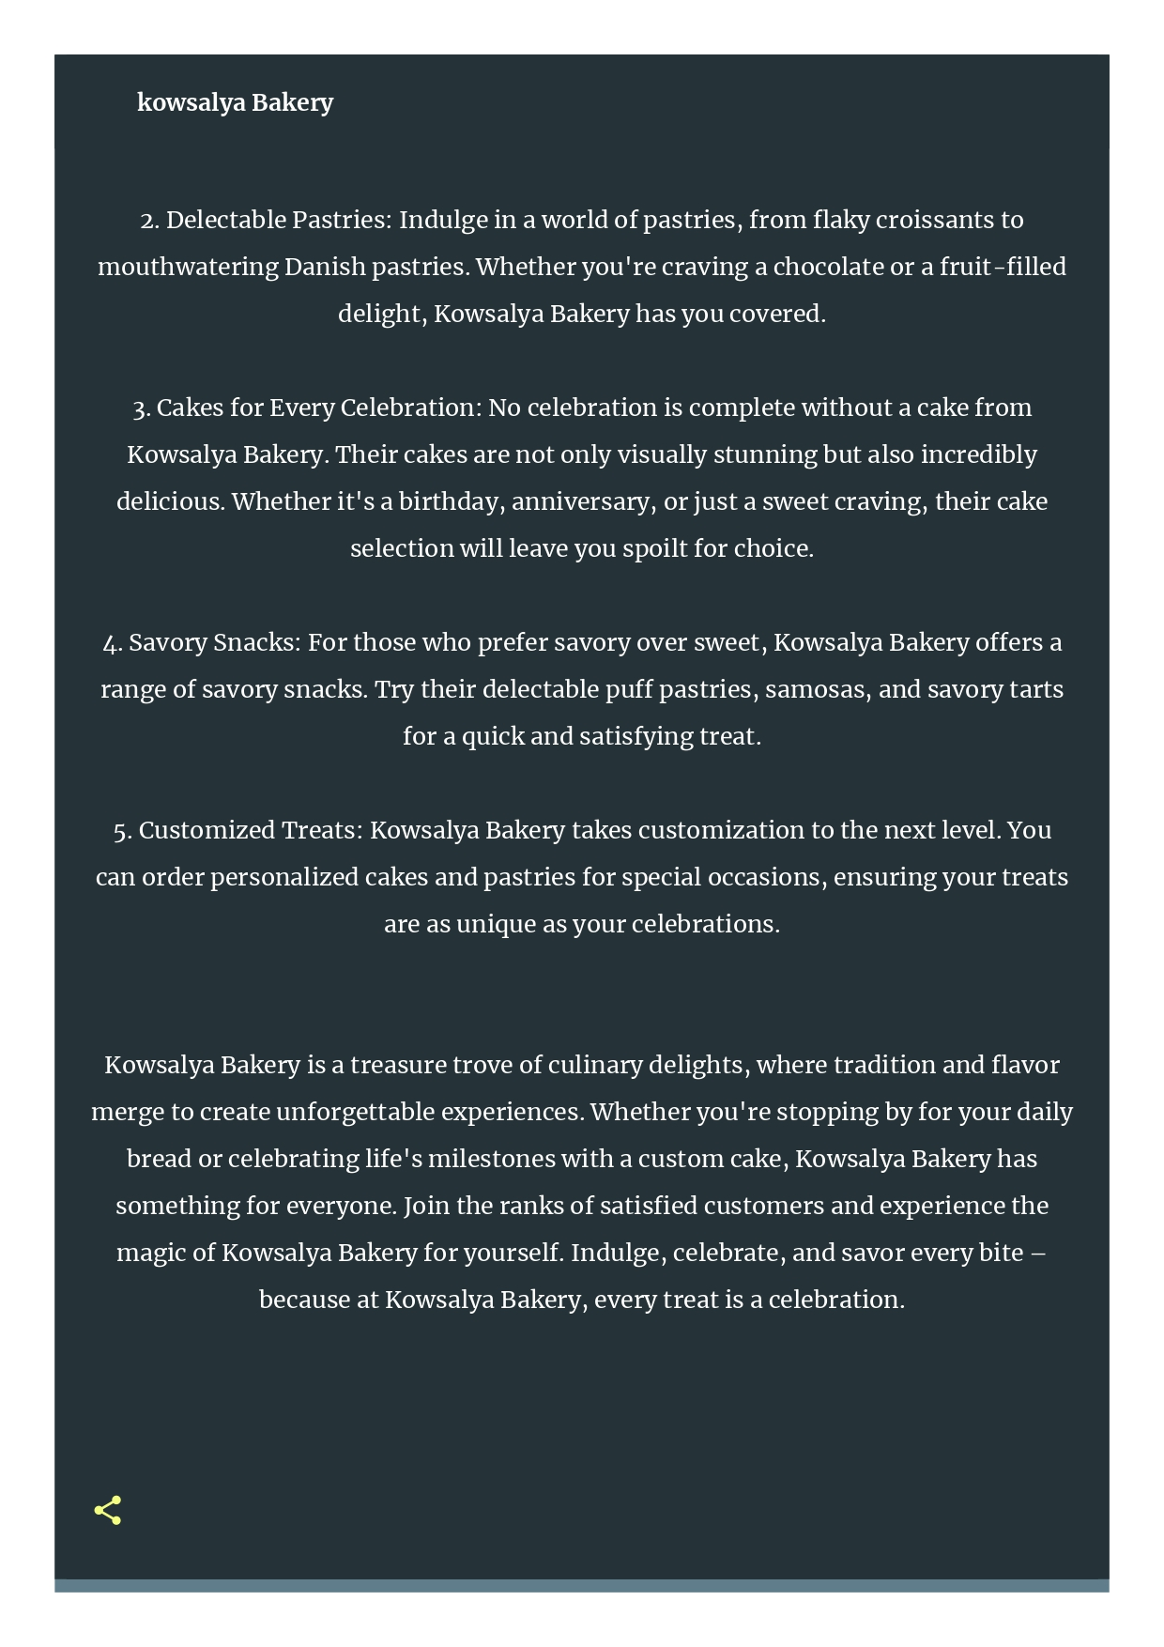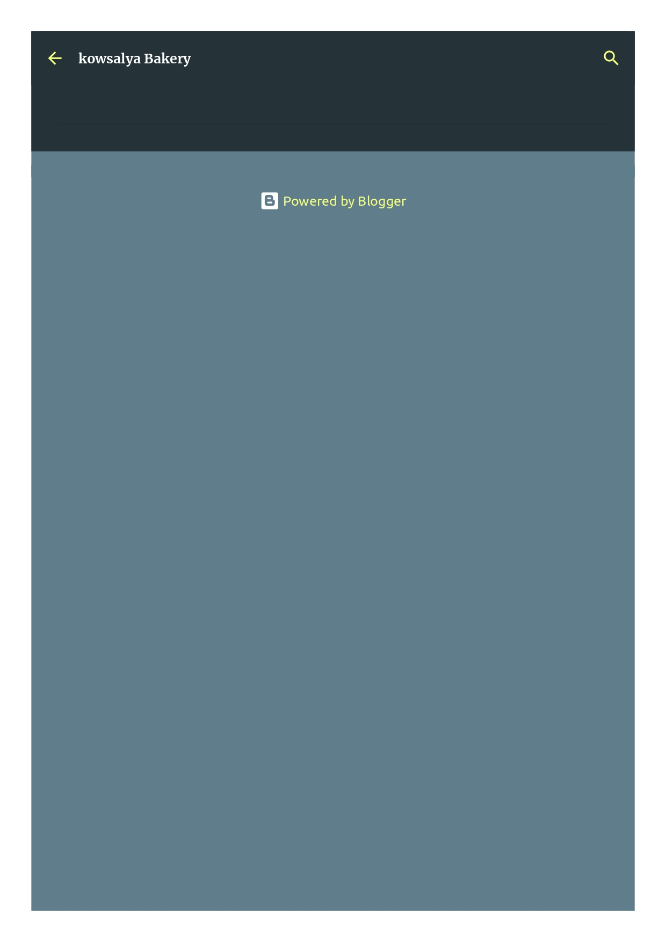

1. Create a New Facebook Business Page and post one social media poster for your brand.

Link: https://www.facebook.com/profile.php?id=61553097322520

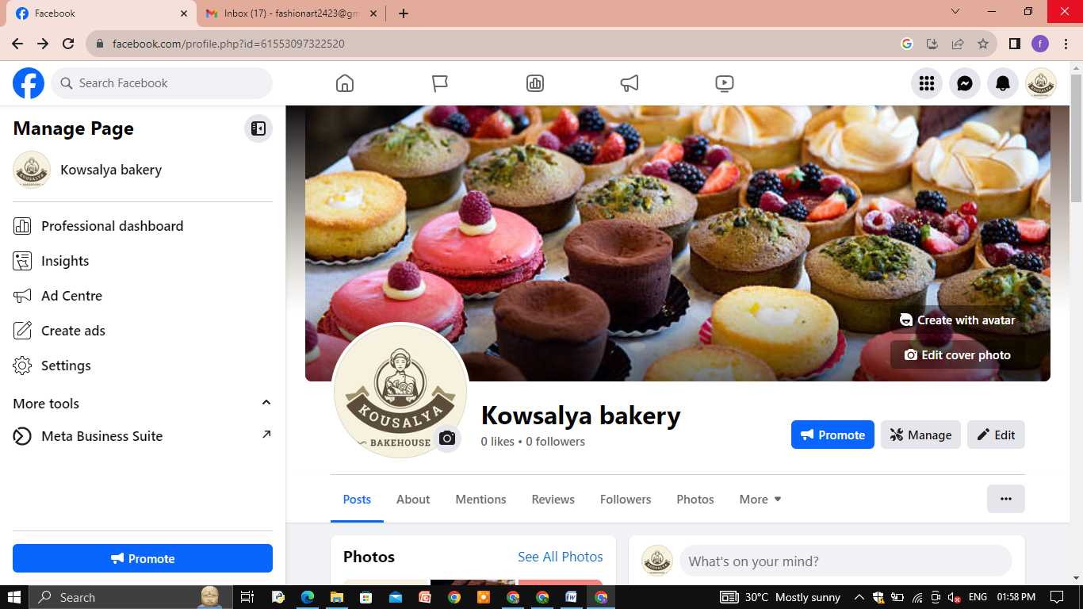

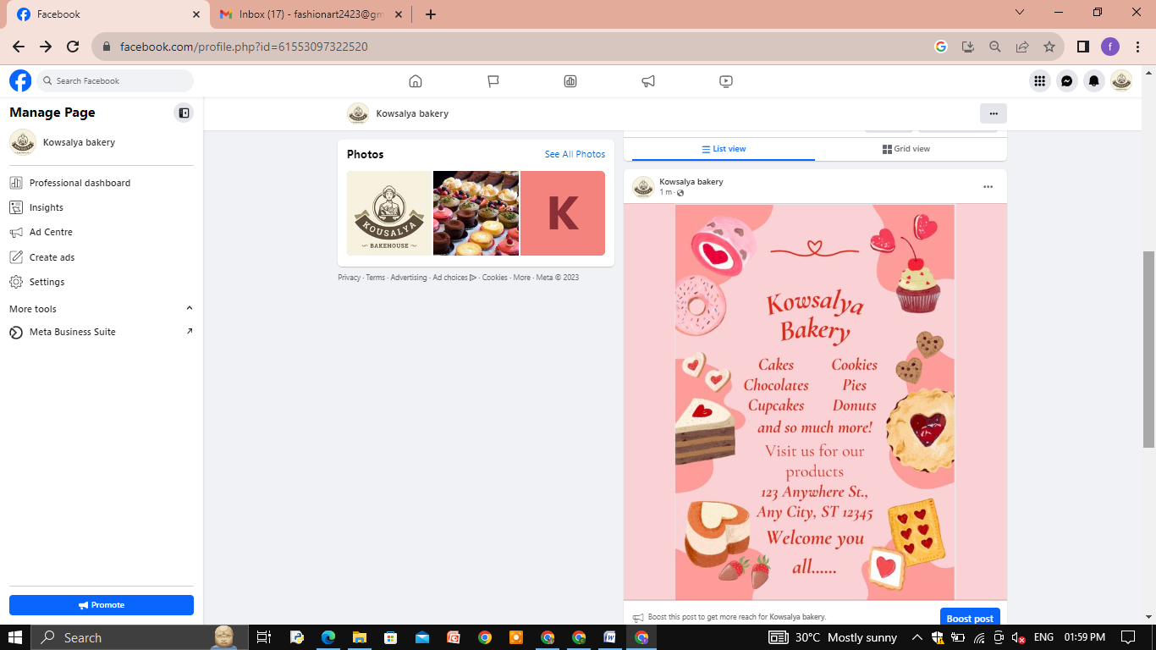

3.Create and design a social media advertisement poster using canva.

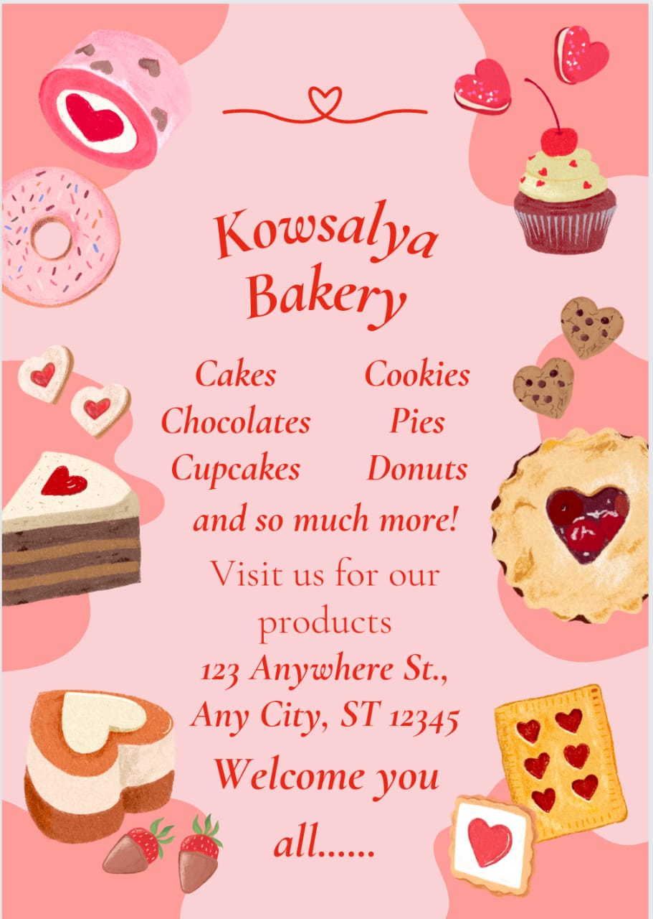

4.Create email newsletter design using MailChimp or canva tool.

Link: <https://kowsalyabakery.blogspot.com/2023/10/kowsalya-bakery-newsletter.html>

